**Design of Instrumentation Amplifier**

**Exp No: 3 Date: 4/02/2021**

**Objective:**

**To design, simulate and verify instrumentation amplifier**

**Software Required:**

LT Spice - XVII

**Theory:**

An instrumentation amplifier is used to amplify very low-level signals, rejecting noise and interference signals. Examples can be heartbeats, blood pressure, temperature, earthquakes and so on. Therefore, the essential characteristics of a good instrumentation amplifier are as follows.

* Inputs to the **instrumentation amplifiers** will have very low signal energy. Therefore, the instrumentation amplifier should have high gain and should be accurate.
* The gain should be easily adjustable using a single control.
* It must have High Input Impedance and Low Output Impedance to prevent loading.
* The Instrumentation amplifier should have High CMRR since the transducer output will usually contain common mode signals such as noise when transmitted over long wires.
* It must also have a High Slew Rate to handle sharp rise times of events and provide a maximum undistorted output voltage swing.

**Instrumentation Amplifier using Op Amp: -**

The **instrumentation amplifier using op-amp circuit** is shown below. The **op-amps** 1 & 2 are non-inverting amplifiers and op-amp 3 is a **difference amplifier**. These three op-amps together, form an instrumentation amplifier. Instrumentation amplifier’s final output Vout is the amplified difference of the input signals applied to the input terminals of op-amp 3. Let the outputs of op-amp 1 and op-amp 2 be Vo1 and Vo2 respectively.

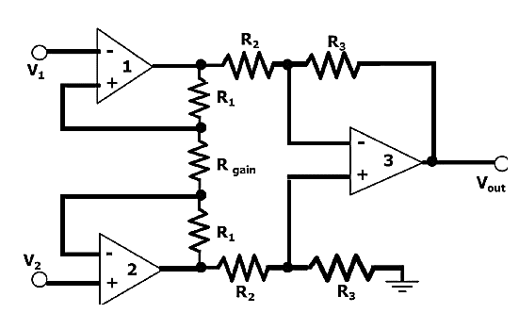

Then, **VOUT = (R3/R2) * (Vo1-Vo2),**

Look at the input stage of the instrumentation amplifier as shown in the figure below. The **instrumentation amplifier derivation** is discussed below.

The potential at node A is the input voltage V1. Hence the potential at node B is also V1, from the virtual short concept. Thus, the potential at node G is also V1.

The potential at node D is the input voltage V2. Hence the potential at node C is also V2, from the virtual short. Thus, the potential at node H is also V2.

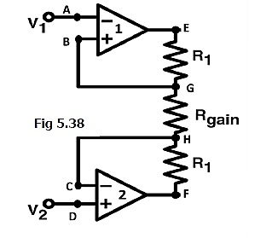

**Input Stage of the Instrumentation Amplifier: -**

The **working of the instrumentation amplifier** is, Ideally the current to the input stage op-amps is zero. Therefore, the current I through the resistors R1, Rgain, and R1 remain the same.

Applying **Ohm’s law** between nodes E and F,

**I = (Vo1-Vo2)/(R1+Rgain+R1)** ……………………….(1)

**I = (Vo1-Vo2)/(2R1+Rgain)**

Since no current is flowing to the input of the op-amps 1 & 2, the current I between the nodes G and H can be given as,

**I = (VG-VH) / Rgain = (V1-V2) / Rgain**……………………….(2)

Equating equations 1 and 2,

**(Vo1-Vo2)/(2R1+Rgain) = (V1-V2)/Rgain**

**(Vo1-Vo2) = (2R1+Rgain)(V1-V2)/Rgain** ……………………….(3)

The output of the difference amplifier is given as,

**Vout = (R3/R2) (Vo1-Vo2)**

Therefore,  **(Vo1 – Vo2) = (R2/R3)Vout**

Substituting  **(Vo1 – Vo2)** value in equation 3, we get

**(R2/R3)Vout = (2R1+Rgain)(V1-V2)/Rgain**

i.e.  **Vout = (R3/R2){(2R1+Rgain)/Rgain}(V1-V2)**

This above equation gives the output voltage of an instrumentation amplifier.

The overall gain of the amplifier is given by the term **(R3/R2){(2R1+Rgain)/Rgain}**.

The overall voltage gain of an **instrumentation amplifier** can be controlled by adjusting the value of resistor **Rgain**.

The common mode signal attenuation for the instrumentation amplifier is provided by the difference amplifier.

**Advantages of Instrumentation Amplifier: -**

The **advantages of the instrumentation amplifier** include the following: -

* The gain of a three op-amp**instrumentation amplifier circuit** can be easily varied by adjusting the value of only one resistor Rgain.
* The gain of the amplifier depends only on the external resistors used.
* The input impedance is very high due to the emitter follower configurations of amplifiers 1 and 2
* The output impedance of the instrumentation amplifier is very low due to the difference amplifier3.
* The CMRR of the **op-amp** 3 is very high and almost all of the common mode signal will be rejected.

**Applications of Instrumentation Amplifier: -**

The **applications of the instrumentation amplifier** include the following.

* These amplifiers mainly involve where the accuracy of high differential gain is required, strength must be preserved in noisy surroundings, as well as where huge common-mode signals are there. Some of the applications are
* Instrumentation amplifiers are used in data acquisition from small o/p transducers like thermocouples, strain gauges, measurements of Wheatstone bridge, etc.
* These amplifiers are used in navigation, medical, radar, etc.
* These amplifiers are used to enhance the **S/N ratio (signal to noise)** in audio applications like audio signals with low amplitude.
* These amplifiers are used for imaging as well as video data acquisition in the conditioning of high-speed signal.
* These amplifiers are used in RF cable systems for amplification of the high-frequency signal.

**Difference between Operational Amplifier and Instrumentation Amplifier: -**

The key differences between the operational amplifier and instrumentation amplifier include the following.

* An[**operational amplifier (op-amp)**](https://www.elprocus.com/operational-amplifiers/) is one kind of an integrated circuit
* The instrumentation amplifier is one type of differential amplifier
* Instrumentation amplifier can be built with three operational amplifiers.
* The differential amplifier can be built with a single operational amplifier.
* The output voltage of difference amplifier gets affected because of the mismatch resistors
* Instrumentation amplifier offers gain with a single resistor of its primary phase which does not need a resistor matching.

**Procedure: -**

* **Open LT Spice and click on new schematic to start the circuit making.**
* **Components needed are: wires, ground, resistor, op-amp and voltage sources.**
* **Place them all in the required way as per the requirement of circuit analysis.**
* **Perform required analysis like transient or ac etc. (simulation commands)**
* **Run the schematic once the circuit is complete**
* **Click above the ac input voltage source for the input signal**
* **Click above the load resistor to obtain the output signal.**
* **Analyse the input and output obtained from the circuit analysis on LT Spice.**
* **Save the schematic and continue further analysis if required.**

**Circuit: -**

**DC Analysis: -**

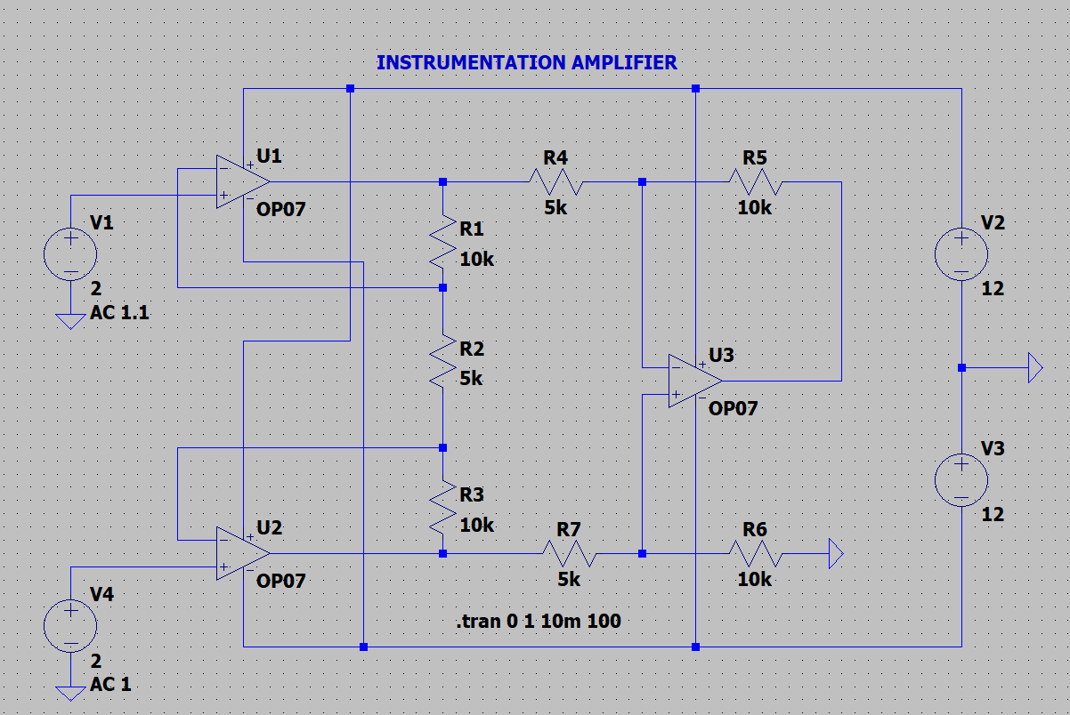

**Input and Outputs: -**

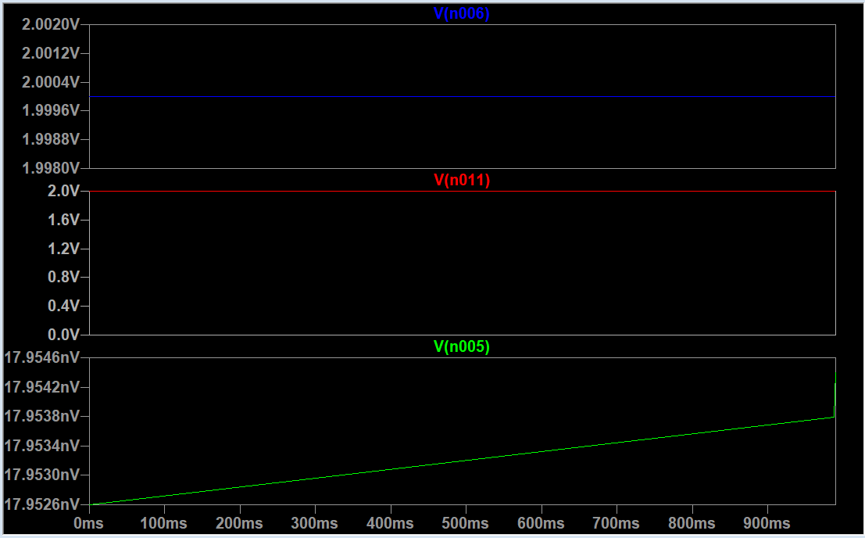

**AC Analysis:**

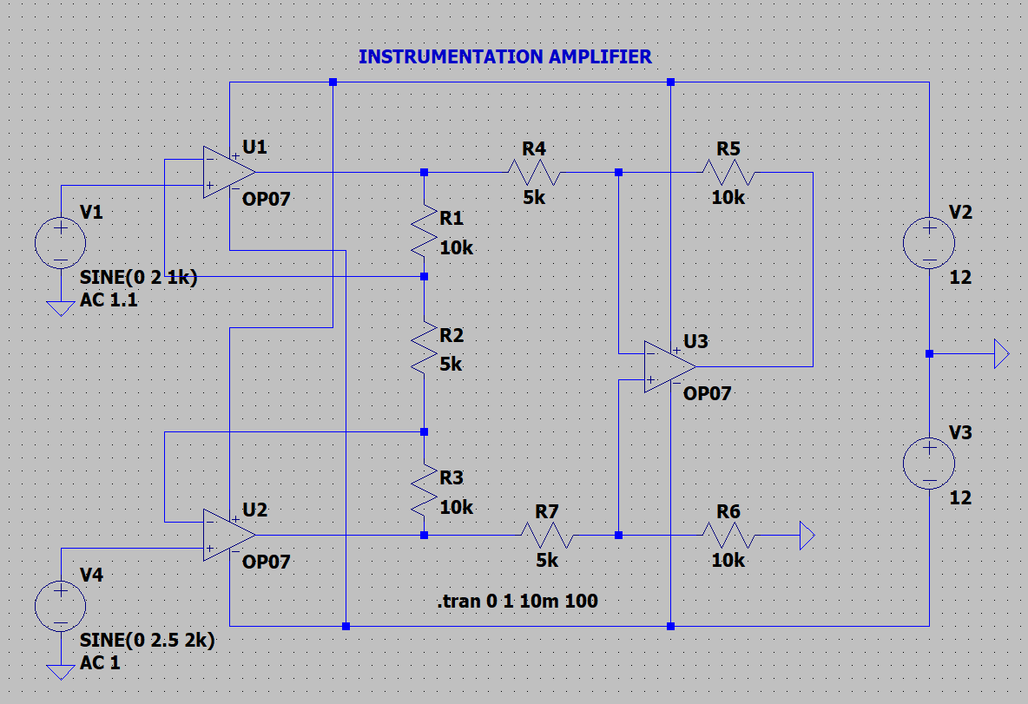

**Input and Output:**

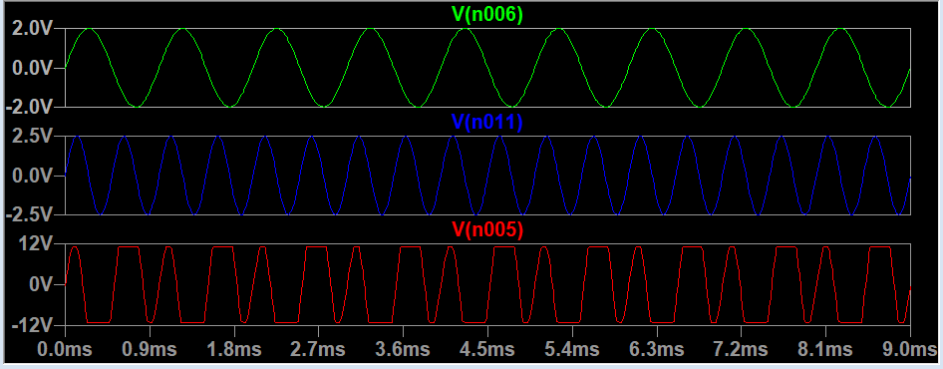

**RESULT: -**

Thus, instrumentation amplifier is designed, tested and verified using LTSPICE.